PowerBI Visuals and DAX

- Explain the Power BI workflow.
Answer: The standard Power BI workflow consists of the following key stages:
- Connect to Data: Import data from various sources (e.g., Excel, SQL databases, web APIs, cloud services).
- Transform and Clean Data (Power Query Editor): Clean, shape, and transform the data (handling missing values, changing data types, merging or appending tables) before loading it into the model.
- Build Data Model: Establish relationships between different tables, create calculated columns, and define measures using DAX (Data Analysis Expressions).
- Create Reports: Design interactive visualizations, charts, and graphs within Power BI Desktop to represent the data insights visually.
- Publish and Share: Publish the reports to the Power BI Service (cloud) to share dashboards, collaborate with team members, and set up scheduled data refreshes.
- Define Data View, Report View, and Model View. Explain the purpose of each view.
Answer: Power BI Desktop has three primary views accessible from the left-hand navigation pane:
- Report View:
  - Definition: The canvas where you design and build interactive visualizations, charts, maps, and dashboards using the data model.
  - Purpose: To create consumer-facing reports and visual stories that help stakeholders analyze trends and insights.
- Data View (formerly Table View):
  - Definition: A view that displays the raw data tables, rows, and columns loaded into the data model.
  - Purpose: To inspect underlying data, write calculated columns, create custom row-level security, or view the detailed contents of individual tables.
- Model View:
  - Definition: A graphical interface showing all tables, fields, and the relationships connecting them.
  - Purpose: To manage table relationships (e.g., one-to-many, many-to-many), configure cross-filter directions, hide columns from report users, and organize data into folders or hierarchies.
- What is a Fact Table and a Dimension Table? Give examples from the dataset.
Answer: Fact Table: A table that stores quantitative, numerical measurements or metrics resulting from a business process or event (e.g., transactions, logs, measurements) along with foreign keys linking to dimension tables.
Dimension Table: A table that stores descriptive attributes (context) about the business entities involved in the facts (e.g., customer details, geography, product categories, time/date).
e.g:
Examples of columns from the actual dataset:
Fact Table | Dimension Table
Confirmed_Cases | Country
Recovered_Cases | State
Deaths | Date
Active_Cases | Vaccination_Status
Tests_Conducted | —
Hospitalized | —

- Create a new column to calculate Recovery Rate.
Answer:

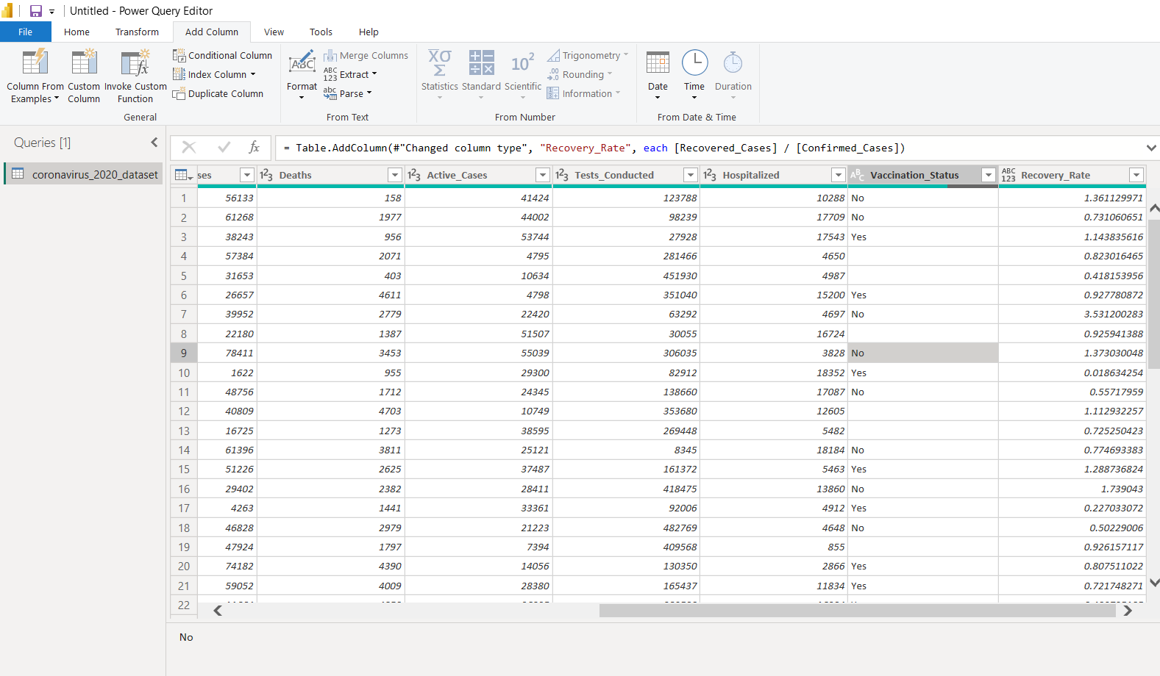
- Create a Line Chart showing the Sales Trend over time (by Month and Year). Is there any noticeable seasonal pattern in sales?
Answer: Creating a line chart:
Drag the date field (e.g., Order Date) into the X-axis (configured to show Year and Month hierarchy) and Sales into the Y-axis of a Line Chart visual.
Seasonal Pattern: Typically, datasets like Global Superstore exhibit strong seasonality towards the end of the year (specifically Q4 / November and December), driven by holiday shopping surges, alongside periodic mid-year sales spikes.

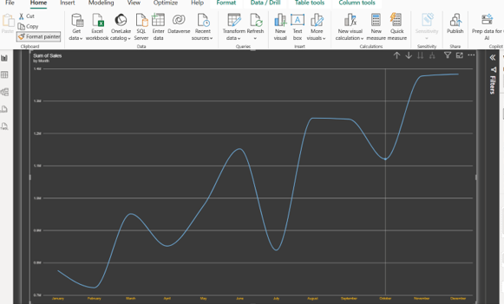
- Create a Scatter Chart to compare Discount vs. Profit by Sub-Category. Are there any outliers where high discounts resulted in negative profit?
Answer: Creating a scattered chart:
Use a Scatter Chart with Discount on the X-axis, Profit on the Y-axis, and Sub-Category (or Product Name) in the Details bucket.
Outliers: Yes, categories (such as Binders or Tables in retail datasets) often display clear outlier behaviour where high discount tiers cross a threshold, dragging total profitability deep into the negative zone due to margins failing to cover the heavy discounts.

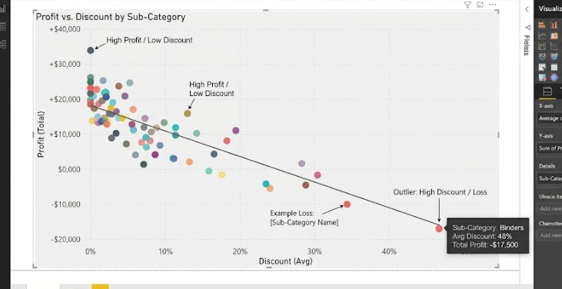

- Use a Waterfall Chart to analyze how Profit changes by Category within the countries.
Answer:
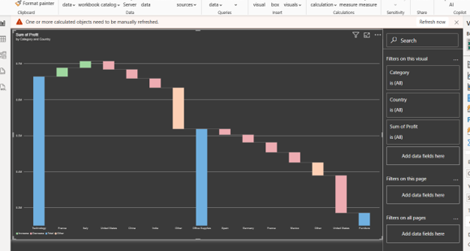

- Create a measure for Average Order Value (AOV).
Answer: 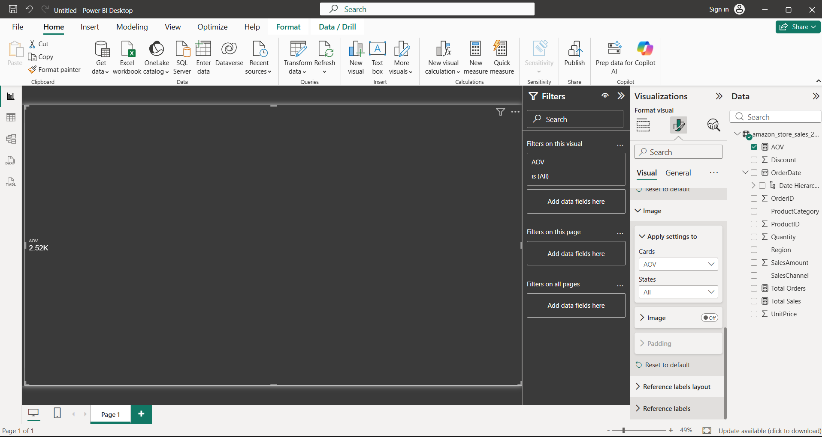

- The Average Order Value (AOV) = 2.52K

- Using DAX, create a measure that calculates cumulative Year-to-Date (YTD) Sales based on the Order Date
Answer: There is a increase in sales throughout each year.
A steady growth from January to December
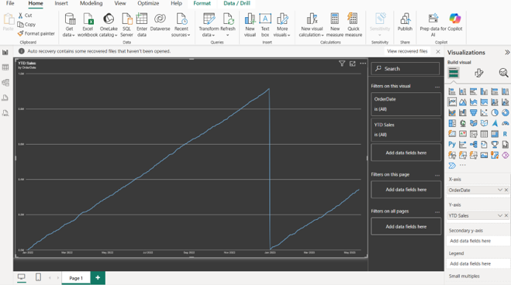

- Using DAX, create a measure to rank each product according to its Total Sales, with the highestselling product ranked first.
Answer: 